**Week 3 Assignment**

Shlok Manandhar

Westcliff University

PRG 402: Mobile Programming Applications

Prof. Khanal

Mar 24, 2025

**jQuery**

jQuery is a fast, lightweight JavaScript library with a good set of plugins for HTML DOM manipulation, event handling, animations and AJAX interactions. The API is very easy, usable across different browsers and reduces complexity of JavaScript code. But with ES6+ + built in browser API usage of it has gone down.

Code:

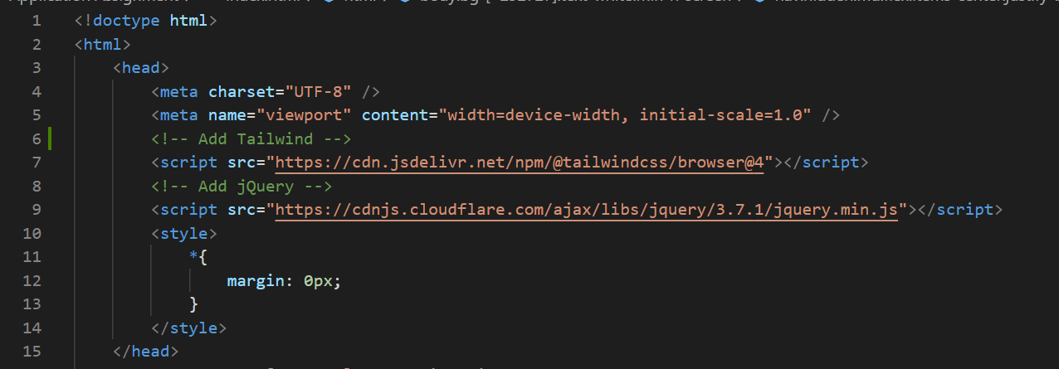

Importing Tailwind CSS and jQuery on the head section

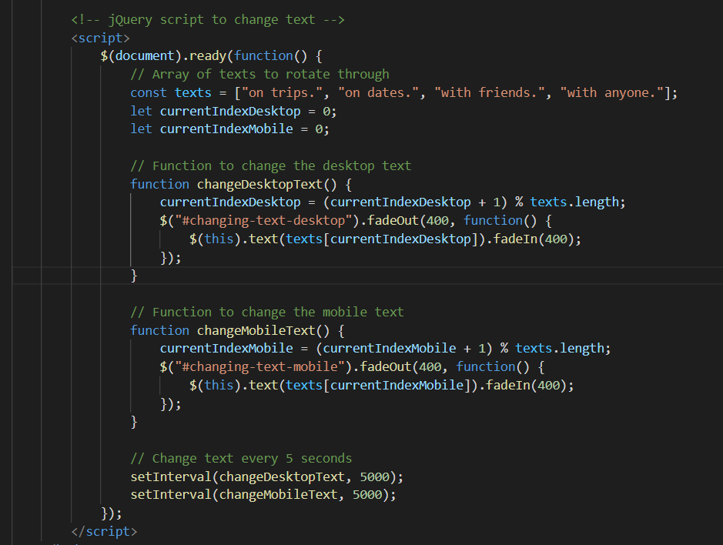

Using jQuery in my code, which changes, a certain text after every 5 seconds.

How it looks



Desktop view.



We can notice that the yellow part of the text which are “with friends”, “on dates”, “on trips”. Changes every 5 second.

Mobile view on iPhone 14 max and on Samsung Galaxy S8+

**References**

Git hub link, on Application Assignment file <https://github.com/ShlokManandhar5/Mobile_App.git>

GeeksforGeeks. (2024, October 7). *Introduction to Tailwind CSS*. GeeksforGeeks. <https://www.geeksforgeeks.org/introduction-to-tailwind-css/>

Gillis, A. S. (2019, March 11). *What is jQuery?* TheServerSide.com. <https://www.theserverside.com/definition/jQuery>